Modélisation Orientée Objet :

Les patrons de conception

ou les « Design Patterns »

Nom : L’usine abstraite (Abstract Factory)
Type : Création
Fréquence d’utilisation : 4/5
Description : Ajoute un niveau d’abstraction pour la création d’objets de telle sorte que le client n’a pas besoin de connaître les classes concrètes des objets.

Diagramme UML :
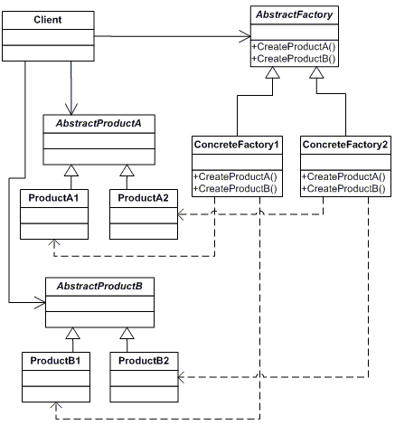

Exemple :

using System;
abstract class ContinentFactory
{
abstract public Herbivore CreateHerbivore();
abstract public Carnivore CreateCarnivore();
}
class AfricaFactory : ContinentFactory
{
override public Herbivore CreateHerbivore()
{
return new Wildebeest();
}
override public Carnivore CreateCarnivore()
{
return new Lion();
}
}
class AmericaFactory : ContinentFactory
{
override public Herbivore CreateHerbivore()
{
return new Bison();
}
override public Carnivore CreateCarnivore()
{
return new Wolf();
}
}
abstract class Herbivore
{
}
abstract class Carnivore
{
abstract public void Eat( Herbivore h );
}
class Wildebeest : Herbivore
{
}
class Lion : Carnivore
{
override public void Eat( Herbivore h )
{
// eat wildebeest
Console.WriteLine( this + " eats " + h );
}
}
class Bison : Herbivore
{
}
class Wolf : Carnivore
{
override public void Eat( Herbivore h )
{
// Eat bison
Console.WriteLine( this + " eats " + h );
}
}

class AnimalWorld
{
// Fields
private Herbivore herbivore;
private Carnivore carnivore;
// Constructors
public AnimalWorld( ContinentFactory factory )
{
carnivore = factory.CreateCarnivore();
herbivore = factory.CreateHerbivore();
}
// Methods
public void RunFoodChain()
{
carnivore.Eat( herbivore );
}
}
class App
{
public static void Main( string[] args )
{
// Create and run the Africa animal world
ContinentFactory africa = new AfricaFactory();
AnimalWorld world = new AnimalWorld( africa );
world.RunFoodChain();
// Create and run the America animal world
ContinentFactory america = new AmericaFactory();
world = new AnimalWorld( america );
world.RunFoodChain();
}
}
Output
Lion eats Wildebeest
Wolf eats Bison

Nom : Constructeur (Builder)
Type : Création
Fréquence d’utilisation : 3/5
Description : Sépare la construction d'un objet complexe de sa représentation de telle sorte que le même procédé de construction puisse créer différentes représentations.
Diagramme UML :

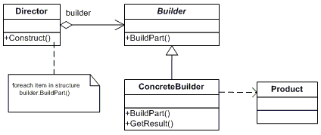

Exemple :

using System;
using System.Collections;
class Shop
{
public void Construct( VehicleBuilder vehicleBuilder )
{
vehicleBuilder.BuildFrame();
vehicleBuilder.BuildEngine();
vehicleBuilder.BuildWheels();
vehicleBuilder.BuildDoors();
}
}
abstract class VehicleBuilder
{
// Fields
protected Vehicle vehicle;
// Properties
public Vehicle Vehicle
{
get{ return vehicle; }
}
// Methods
abstract public void BuildFrame();
abstract public void BuildEngine();
abstract public void BuildWheels();
abstract public void BuildDoors();
}
class MotorCycleBuilder : VehicleBuilder
{
override public void BuildFrame()
{
vehicle = new Vehicle( "MotorCycle" );
vehicle[ "frame" ] = "MotorCycle Frame";
}
override public void BuildEngine()
{
vehicle[ "engine" ] = "500 cc";
}
override public void BuildWheels()
{
vehicle[ "wheels" ] = "2";
}
override public void BuildDoors()
{
vehicle[ "doors" ] = "0";
}
}
class CarBuilder : VehicleBuilder
{
override public void BuildFrame()
{
vehicle = new Vehicle( "Car" );
vehicle[ "frame" ] = "Car Frame";
}
override public void BuildEngine()
{
vehicle[ "engine" ] = "2500 cc";
}
override public void BuildWheels()
{
vehicle[ "wheels" ] = "4";
}
override public void BuildDoors()
{
vehicle[ "doors" ] = "4";
}
}
class ScooterBuilder : VehicleBuilder
{
override public void BuildFrame()
{
vehicle = new Vehicle( "Scooter" );
vehicle[ "frame" ] = "Scooter Frame";
}
override public void BuildEngine()
{
vehicle[ "engine" ] = "none";
}
override public void BuildWheels()
{
vehicle[ "wheels" ] = "2";
}
override public void BuildDoors()
{
vehicle[ "doors" ] = "0";
}
}
class Vehicle
{
// Fields
private string type;
private Hashtable parts = new Hashtable();
// Constructors
public Vehicle( string type )
{
this.type = type;
}
// Indexers
public object this[ string key ]
{
get{ return parts[ key ]; }
set{ parts[ key ] = value; }
}
// Methods
public void Show()
{
Console.WriteLine( "\n---------------------------");
Console.WriteLine( "Vehicle Type: "+ type );
Console.WriteLine( " Frame : " + parts[ "frame" ] );
Console.WriteLine( " Engine : "+ parts[ "engine"] );
Console.WriteLine( " #Wheels: "+ parts[ "wheels"] );
Console.WriteLine( " #Doors : "+ parts[ "doors" ] );
}
}
public class App
{
public static void Main( string[] args )
{
// Create shop and vehicle builders
Shop shop = new Shop();
VehicleBuilder b1 = new ScooterBuilder();
VehicleBuilder b2 = new CarBuilder();
VehicleBuilder b3 = new MotorCycleBuilder();
// Construct and display vehicles
shop.Construct( b1 );
b1.Vehicle.Show();
shop.Construct( b2 );
b2.Vehicle.Show();
shop.Construct( b3 );
b3.Vehicle.Show();
}
}
Output
---------------------------
Vehicle Type: Scooter
Frame : Scooter Frame
Engine : none
#Wheels: 2
#Doors : 0
---------------------------
Vehicle Type: Car
Frame : Car Frame
Engine : 2500 cc
#Wheels: 4
#Doors : 4
---------------------------
Vehicle Type: MotorCycle
Frame : MotorCycle Frame
Engine : 500 cc
#Wheels: 2
#Doors : 0

Nom : Méthode-usine (Factory Method)
Type : Création
Fréquence d’utilisation : 4/5
Description : Définit une interface pour créer des objets mais laisse la classe dérivée décider de la classe à instancier. La méthode-usine délègue l’instanciation à une classe dérivée.
Diagramme UML :

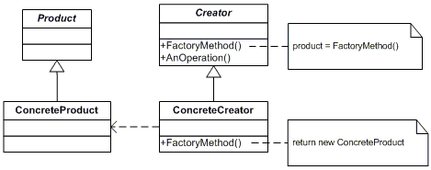

Exemple :

using System;
using System.Collections;
abstract class Page
{
}
class SkillsPage : Page
{
}
class EducationPage : Page
{
}
class ExperiencePage : Page
{
}
class IntroductionPage : Page
{
}
class ResultsPage : Page
{
}
class ConclusionPage : Page
{
}
class SummaryPage : Page
{
}
class BibliographyPage : Page
{
}
abstract class Document
{
// Fields
protected ArrayList pages = new ArrayList();
// Constructor
public Document()
{
this.CreatePages();
}
// Properties
public ArrayList Pages
{
get{ return pages; }
}
// Factory Method
abstract public void CreatePages();
}
class Resume : Document
{
// Factory Method implementation
override public void CreatePages()
{
pages.Add( new SkillsPage() );
pages.Add( new EducationPage() );
pages.Add( new ExperiencePage() );
}
}
class Report : Document
{
// Factory Method implementation
override public void CreatePages()
{
pages.Add( new IntroductionPage() );
pages.Add( new ResultsPage() );
pages.Add( new ConclusionPage() );
pages.Add( new SummaryPage() );
pages.Add( new BibliographyPage() );
}
}
class App
{
public static void Main( string[] args )
{
Document[] docs = new Document[ 2 ];
// Note: constructors call Factory Method
docs[0] = new Resume();
docs[1] = new Report();
// Display document pages
foreach( Document document in docs )
{
Console.WriteLine( "\n" + document + " ------- " );
foreach( Page page in document.Pages )
Console.WriteLine( " " + page );
}
}
}
Output
Resume -------
SkillsPage
EducationPage
ExperiencePage
Report -------
IntroductionPage
ResultsPage
ConclusionPage
SummaryPage
BibliographyPage

Nom : Singleton (Singleton)
Type : Création
Fréquence d’utilisation : 5/5
Description : Assure que la classe n’a qu’une seule instance et présente une façon standard d’y accéder.
Diagramme UML :

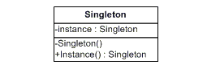

Exemple :

using System;
using System.Collections;
using System.Threading;
class LoadBalancer
{
// Fields
private static LoadBalancer balancer;
private ArrayList servers = new ArrayList();
private Random random = new Random();
// Constructors (protected)
protected LoadBalancer()
{
// List of available servers
servers.Add( "ServerI" );
servers.Add( "ServerII" );
servers.Add( "ServerIII" );
servers.Add( "ServerIV" );
servers.Add( "ServerV" );
}
// Methods
public static LoadBalancer GetLoadBalancer()
{
// Support multithreaded applications through
// "Double checked locking" pattern which avoids
// locking every time the method is invoked
if( balancer == null )
{
// Only one thread can obtain a mutex
Mutex mutex = new Mutex();
mutex.WaitOne();
if( balancer == null )
balancer = new LoadBalancer();
mutex.Close();
}
return balancer;
}
// Properties
public string Server
{
get
{
// Simple, but effective random load balancer
int r = random.Next( servers.Count );
return servers[ r ].ToString();
}
}
}
public class App
{
public static void Main( string[] args )
{
LoadBalancer b1 = LoadBalancer.GetLoadBalancer();
LoadBalancer b2 = LoadBalancer.GetLoadBalancer();
LoadBalancer b3 = LoadBalancer.GetLoadBalancer();
LoadBalancer b4 = LoadBalancer.GetLoadBalancer();
// Same instance?
if( (b1 == b2) && (b2 == b3) && (b3 == b4) )
Console.WriteLine( "Same instance" );
// Do the load balancing
Console.WriteLine( b1.Server );
Console.WriteLine( b2.Server );
Console.WriteLine( b3.Server );
Console.WriteLine( b4.Server );
}
}
Output
Same instance
ServerV
ServerIII
ServerIII
ServerIV

Nom : Adaptateur (Adapter)
Type : Structure
Fréquence d’utilisation : 4/5
Description : Adapter l’interface d’une classe aux attentes d’une autre classe. Permet à des classes aux interfaces incompatibles de travailler ensemble.

Diagramme UML :

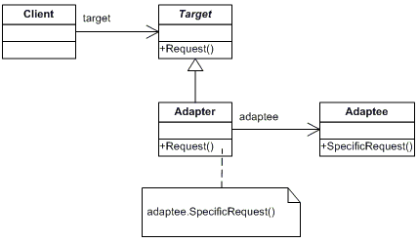

Exemple :

using System;
class ChemicalCompound
{
// Fields
protected string name;
protected float boilingPoint;
protected float meltingPoint;
protected double molecularWeight;
protected string molecularFormula;
// Constructors
public ChemicalCompound( string name )
{
this.name = name;
}
// Properties
public float BoilingPoint
{
get{ return boilingPoint; }
}
public float MeltingPoint
{
get{ return meltingPoint; }
}
public double MolecularWeight
{
get{ return molecularWeight; }
}
public string MolecularFormula
{
get{ return molecularFormula; }
}
}
class Compound : ChemicalCompound
{
// Fields
private ChemicalDatabank bank;
// Constructors
public Compound( string name ) : base( name )
{
// Adaptee
bank = new ChemicalDatabank();
// Adaptee request methods
boilingPoint = bank.GetCriticalPoint( name, "B" );
meltingPoint = bank.GetCriticalPoint( name, "M" );
molecularWeight = bank.GetMolecularWeight( name );
molecularFormula = bank.GetMolecularStructure( name );
}
// Methods
public void Display()
{
Console.WriteLine("\nCompound: {0} ------ ",name );
Console.WriteLine(" Formula: {0}",MolecularFormula);
Console.WriteLine(" Weight : {0}",MolecularWeight );
Console.WriteLine(" Melting Pt: {0}",MeltingPoint );
Console.WriteLine(" Boiling Pt: {0}",BoilingPoint );
}
}
class ChemicalDatabank
{
// Methods -- the Databank 'legacy API'
public float GetCriticalPoint( string compound, string point )
{
float temperature = 0.0F;
// Melting Point
if( point == "M" )
{
switch( compound.ToLower() )
{
case "water": temperature = 0.0F; break;
case "benzene" : temperature = 5.5F; break;
case "alcohol": temperature = -114.1F; break;
}
}
// Boiling Point
else
{
switch( compound.ToLower() )
{
case "water": temperature = 100.0F;break;
case "benzene" : temperature = 80.1F; break;
case "alcohol": temperature = 78.3F; break;
}
}
return temperature;
}
public string GetMolecularStructure( string compound )
{
string structure = "";
switch( compound.ToLower() )
{
case "water": structure = "H20"; break;
case "benzene" : structure = "C6H6"; break;
case "alcohol": structure = "C2H6O2"; break;
}
return structure;
}
public double GetMolecularWeight( string compound )
{
double weight = 0.0;
switch( compound.ToLower() )
{
case "water": weight = 18.015; break;
case "benzene" : weight = 78.1134; break;
case "alcohol": weight = 46.0688; break;
}
return weight;
}
}
public class App
{
public static void Main(string[] args)
{
// Retrieve and display water characteristics
Compound water = new Compound( "Water" );
water.Display();
// Retrieve and display benzene characteristics
Compound benzene = new Compound( "Benzene" );
benzene.Display();
// Retrieve and display alcohol characteristics
Compound alcohol = new Compound( "Alcohol" );
alcohol.Display();
}
}
Output
Compound: Water ------
Formula: H20
Weight : 18.015
Melting Pt: 0
Boiling Pt: 100
Compound: Benzene ------
Formula: C6H6
Weight : 78.1134
Melting Pt: 5.5
Boiling Pt: 80.1
Compound: Alcohol ------
Formula: C2H6O2
Weight : 46.0688
Melting Pt: -114.1
Boiling Pt: 78.3

Nom : Pont (Bridge)
Type : Structure
Fréquence d’utilisation : 3/5
Description : Sépare une abstraction de son implémentation pour qu’ils puissent varier de façon indépendante.

Diagramme UML :

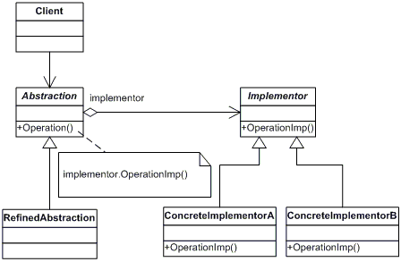

Exemple :

using System;
using System.Collections;
class BusinessObject
{
// Fields
private DataObject dataObject;
protected string group;
// Constructors
public BusinessObject( string group )
{
this.group = group;
}
// Properties
public DataObject DataObject
{
set{ dataObject = value; }
get{ return dataObject; }
}
// Methods
virtual public void Next()
{
dataObject.NextRecord();
}
virtual public void Prior()
{
dataObject.PriorRecord();
}
virtual public void New( string name )
{
dataObject.NewRecord( name );
}
virtual public void Delete( string name )
{
dataObject.DeleteRecord( name );
}
virtual public void Show()
{
dataObject.ShowRecord();
}
virtual public void ShowAll()
{
Console.WriteLine( "Customer Group: {0}", group );
dataObject.ShowAllRecords();
}
}
class CustomersBusinessObject : BusinessObject
{
// Constructors
public CustomersBusinessObject( string group )
: base( group ){}
// Methods
override public void ShowAll()
{
// Add separator lines
Console.WriteLine();
Console.WriteLine( "------------------------" );
base.ShowAll();
Console.WriteLine( "------------------------" );
}
}
abstract class DataObject
{
// Methods
abstract public void NextRecord();
abstract public void PriorRecord();
abstract public void NewRecord( string name );
abstract public void DeleteRecord( string name );
abstract public void ShowRecord();
abstract public void ShowAllRecords();
}
class CustomersDataObject : DataObject
{
// Fields
private ArrayList customers = new ArrayList();
private int current = 0;
// Constructors
public CustomersDataObject()
{
// Loaded from a database
customers.Add( "Jim Jones" );
customers.Add( "Samual Jackson" );
customers.Add( "Allen Good" );
customers.Add( "Ann Stills" );
customers.Add( "Lisa Giolani" );
}
// Methods
public override void NextRecord()
{
if( current <= customers.Count - 1 )
current++;
}
public override void PriorRecord()
{
if( current > 0 )
current--;
}
public override void NewRecord( string name )
{
customers.Add( name );
}
public override void DeleteRecord( string name )
{
customers.Remove( name );
}
public override void ShowRecord()
{
Console.WriteLine( customers[ current ] );
}
public override void ShowAllRecords()
{
foreach( string name in customers )
Console.WriteLine( " " + name );
}
}
public class App
{
public static void Main( string[] args )
{
// Create RefinedAbstraction
CustomersBusinessObject customers =
new CustomersBusinessObject(" Chicago ");
// Set ConcreteImplementor
customers.DataObject = new CustomersDataObject();
// Exercise the bridge
customers.Show();
customers.Next();
customers.Show();
customers.Next();
customers.Show();
customers.New( "Henry Velasquez" );
customers.ShowAll();
}
}
Output
Jim Jones
Samual Jackson
Allen Good
------------------------
Customer Group: Chicago
Jim Jones
Samual Jackson
Allen Good
Ann Stills
Lisa Giolani
Henry Velasquez
------------------------

Nom : Composition (Composite)
Type : Structure
Fréquence d’utilisation : 5/5
Description : Utilise la structure d’arbre pour représenter les hiérarchies de type tout-parties. La composition permet au client de manipuler de façon transparente des objets simples et des objets composés.

Diagramme UML :

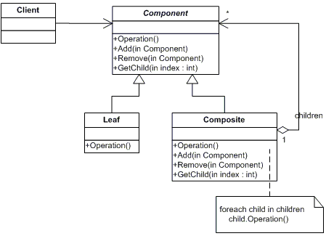

Exemple :

using System;
using System.Collections;
abstract class DrawingElement
{
// Fields
protected string name;
// Constructors
public DrawingElement( string name )
{
this.name = name;
}
// Methods
abstract public void Add( DrawingElement d );
abstract public void Remove( DrawingElement d );
abstract public void Display( int indent );
}
class PrimitiveElement : DrawingElement
{
// Constructors
public PrimitiveElement( string name ) : base( name ) {}
// Methods
public override void Add( DrawingElement c )
{
Console.WriteLine("Cannot Add");
}
public override void Remove( DrawingElement c )
{
Console.WriteLine("Cannot Remove");
}
public override void Display( int indent )
{
Console.WriteLine( new String( '-', indent ) +
" draw a {0}", name );
}
}
class CompositeElement : DrawingElement
{
// Fields
private ArrayList elements = new ArrayList();
// Constructors
public CompositeElement( string name )
: base( name ) {}
// Methods
public override void Add( DrawingElement d )
{
elements.Add( d );
}
public override void Remove( DrawingElement d )
{
elements.Remove( d );
}
public override void Display( int indent )
{
Console.WriteLine( new String( '-', indent ) +
"+ " + name );
// Display each child element on this node
foreach( DrawingElement c in elements )
c.Display( indent + 2 );
}
}
public class App
{
public static void Main( string[] args )
{
// Create a tree structure
CompositeElement root = new
CompositeElement( "Picture" );
root.Add( new PrimitiveElement( "Red Line" ));
root.Add( new PrimitiveElement( "Blue Circle" ));
root.Add( new PrimitiveElement( "Green Box" ));
CompositeElement comp = new
CompositeElement( "Two Circles" );
comp.Add( new PrimitiveElement( "Black Circle" ) );
comp.Add( new PrimitiveElement( "White Circle" ) );
root.Add( comp );
// Add and remove a PrimitiveElement
PrimitiveElement l = new
PrimitiveElement( "Yellow Line" );
root.Add( l );
root.Remove( l );
// Recursively display nodes
root.Display( 1 );
}
}
Output
-+ Picture
--- draw a Red Line
--- draw a Blue Circle
--- draw a Green Box
---+ Two Circles
----- draw a Black Circle
----- draw a White Circle

Nom : Décorateur (Decorator)
Type : Structure
Fréquence d’utilisation : 4/5
Description : Ajoute dynamiquement des responsabilités à un objet. Décorateur est une alternative flexible à la dérivation pour étendre les fonctionnalités d’un objet.

Diagramme UML :

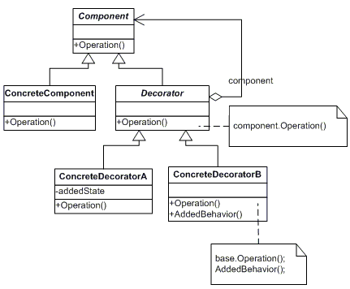

Exemple :

using System;
using System.Collections;
abstract class LibraryItem
{
// Fields
private int numCopies;
// Properties
public int NumCopies
{
get{ return numCopies; }
set{ numCopies = value; }
}
// Methods
public abstract void Display();
}
class Book : LibraryItem
{
// Fields
private string author;
private string title;
// Constructors
public Book(string author,string title,int numCopies)
{
this.author = author;
this.title = title;
this.NumCopies = numCopies;
}
// Methods
public override void Display()
{
Console.WriteLine( "\nBook ------ " );
Console.WriteLine( " Author: {0}", author );
Console.WriteLine( " Title: {0}", title );
Console.WriteLine( " # Copies: {0}", NumCopies );
}
}
class Video : LibraryItem
{
// Fields
private string director;
private string title;
private int playTime;
// Constructor
public Video( string director, string title,
int numCopies, int playTime )
{
this.director = director;
this.title = title;
this.NumCopies = numCopies;
this.playTime = playTime;
}
// Methods
public override void Display()
{
Console.WriteLine( "\nVideo ----- " );
Console.WriteLine( " Director: {0}", director );
Console.WriteLine( " Title: {0}", title );
Console.WriteLine( " # Copies: {0}", NumCopies );
Console.WriteLine( " Playtime: {0}", playTime );
}
}
abstract class Decorator : LibraryItem
{
// Fields
protected LibraryItem libraryItem;
// Constructors
public Decorator ( LibraryItem libraryItem )
{
this.libraryItem = libraryItem;
}
// Methods
public override void Display()
{
libraryItem.Display();
}
}
class Borrowable : Decorator
{
// Fields
protected ArrayList borrowers = new ArrayList();
// Constructors
public Borrowable( LibraryItem libraryItem )
: base( libraryItem ) {}
// Methods
public void BorrowItem( string name )
{
borrowers.Add( name );
libraryItem.NumCopies--;
}
public void ReturnItem( string name )
{
borrowers.Remove( name );
libraryItem.NumCopies++;
}
public override void Display()
{
base.Display();
foreach( string borrower in borrowers )
Console.WriteLine( " borrower: {0}", borrower );
}
}
public class App
{
public static void Main( string[] args )
{
// Create book and video and display
Book book = new Book( "Schnell", "My Home", 10 );
Video video = new Video( "Spielberg",
"Schindler's list", 23, 60 );
book.Display();
video.Display();
// Make video borrowable, then borrow and display
Console.WriteLine( "\nVideo made borrowable:" );
Borrowable borrowvideo = new Borrowable( video );
borrowvideo.BorrowItem( "Cindy Lopez" );
borrowvideo.BorrowItem( "Samuel King" );
borrowvideo.Display();
}
}
Output
Book ------
Author: Schnell
Title: My Home
# Copies: 10
Video -----
Director: Spielberg
Title: Schindler's list
# Copies: 23
Playtime: 60
Video made borrowable:
Video -----
Director: Spielberg
Title: Schindler's list
# Copies: 21
Playtime: 60
borrower: Cindy Lopez
borrower: Samuel King

Nom : Façade (Façade)
Type : Structure
Fréquence d’utilisation : 5/5
Description : Regroupe l’ensemble des interfaces d’un sous-système en une interface unifiée. Façade définie une interface de haut niveau pour simplifier l’utilisation d’un sous-système.
Diagramme UML :

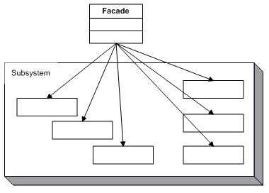

Exemple :

using System;
class Bank
{
// Methods
public bool SufficientSavings( Customer c )
{
Console.WriteLine("Check bank for {0}", c.Name );
return true;
}
}
class Credit
{
// Methods
public bool GoodCredit( int amount, Customer c )
{
Console.WriteLine( "Check credit for {0}", c.Name );
return true;
}
}
class Loan
{
// Methods
public bool GoodLoan( Customer c )
{
Console.WriteLine( "Check loan for {0}", c.Name );
return true;
}
}
class Customer
{
// Fields
private string name;
// Constructors
public Customer( string name )
{
this.name = name;
}
// Properties
public string Name
{
get{ return name; }
}
}
class MortgageApplication
{
// Fields
int amount;
private Bank bank = new Bank();
private Loan loan = new Loan();
private Credit credit = new Credit();
// Constructors
public MortgageApplication( int amount )
{
this.amount = amount;
}
// Methods
public bool IsEligible( Customer c )
{
// Check creditworthyness of applicant
if( !bank.SufficientSavings( c ) )
return false;
if( !loan.GoodLoan( c ) )
return false;
if( !credit.GoodCredit( amount, c ))
return false;
return true;
}
}
public class App
{
public static void Main(string[] args)
{
// Create Facade
MortgageApplication mortgage =
new MortgageApplication( 125000 );
// Call subsystem through Facade
mortgage.IsEligible(
new Customer( "Gabrielle McKinsey" ) );
}
}
Output
Check bank for Gabrielle McKinsey
Check loan for Gabrielle McKinsey
Check credit for Gabrielle McKinsey

Nom : Procuration (Proxy)
Type : Structure
Fréquence d’utilisation : 5/5
Description : Défini une nouvelle interface à un objet réel afin d’en protéger l’accès ou de cacher certaines informations.
Diagramme UML :

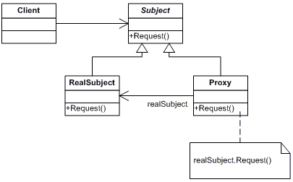

Exemple :

using System;
using System.Runtime.Remoting;
public interface IMath
{
// Methods
double Add( double x, double y );
double Sub( double x, double y );
double Mul( double x, double y );
double Div( double x, double y );
}
class Math : MarshalByRefObject, IMath
{
// Methods
public double Add(double x, double y ){ return x + y; }
public double Sub(double x, double y ){ return x - y; }
public double Mul(double x, double y ){ return x * y; }
public double Div(double x, double y ){ return x / y; }
}
class MathProxy : IMath
{
// Fields
Math math;
// Constructors
public MathProxy()
{
// Create Math instance in a different AppDomain
AppDomain ad = System.AppDomain.CreateDomain(
"MathDomain",null, null );
ObjectHandle o =
ad.CreateInstance("Proxy_RealWorld", "Math", false,
System.Reflection.BindingFlags.CreateInstance,
null, null, null,null,null );
math = (Math) o.Unwrap();
}
// Methods
public double Add( double x, double y )
{
return math.Add(x,y);
}
public double Sub( double x, double y )
{
return math.Sub(x,y);
}
public double Mul( double x, double y )
{
return math.Mul(x,y);
}
public double Div( double x, double y )
{
return math.Div(x,y);
}
}
public class App
{
public static void Main( string[] args )
{
// Create math proxy
MathProxy p = new MathProxy();
// Do the math
Console.WriteLine( "4 + 2 = {0}", p.Add( 4, 2 ) );
Console.WriteLine( "4 - 2 = {0}", p.Sub( 4, 2 ) );
Console.WriteLine( "4 * 2 = {0}", p.Mul( 4, 2 ) );
Console.WriteLine( "4 / 2 = {0}", p.Div( 4, 2 ) );
}
}
Output
4 + 2 = 6
4 - 2 = 2
4 * 2 = 8
4 / 2 = 2

Nom : Chaîne de responsabilités (Chain of Responsibility)
Type : Comportement
Fréquence d’utilisation : 3/5
Description : Offre l’opportunité à plusieurs objets ordonnées à l’intérieur d’une chaîne de traiter une requête et/ou de passer cette requête à l’objet suivant.
Diagramme UML :

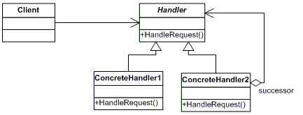

Exemple :

using System;
abstract class Approver
{
// Fields
protected string name;
protected Approver successor;
// Constructors
public Approver( string name )
{
this.name = name;
}
// Methods
public void SetSuccessor( Approver successor )
{
this.successor = successor;
}
abstract public void ProcessRequest(
PurchaseRequest request );
}
class Director : Approver
{
// Constructors
public Director ( string name ) : base( name ) {}
// Methods
override public void ProcessRequest(
PurchaseRequest request )
{
if( request.Amount < 10000.0 )
Console.WriteLine( "{0} {1} approved request# {2}",
this, name, request.Number);
else
if( successor != null )
successor.ProcessRequest( request );
}
}
class VicePresident : Approver
{
// Constructors
public VicePresident ( string name ) : base( name ) {}
// Methods
override public void ProcessRequest(
PurchaseRequest request )
{
if( request.Amount < 25000.0 )
Console.WriteLine( "{0} {1} approved request# {2}",
this, name, request.Number);
else
if( successor != null )
successor.ProcessRequest( request );
}
}
class President : Approver
{
// Constructors
public President ( string name ) : base( name ) {}
// Methods
override public void ProcessRequest(
PurchaseRequest request )
{
if( request.Amount < 100000.0 )
Console.WriteLine( "{0} {1} approved request# {2}",
this, name, request.Number);
else
Console.WriteLine( "Request# {0} requires " +
"an executive meeting!", request.Number );
}
}
class PurchaseRequest
{
// Member Fields
private int number;
private double amount;
private string purpose;
// Constructors
public PurchaseRequest( int number,
double amount, string purpose )
{
this.number = number;
this.amount = amount;
this.purpose = purpose;
}
// Properties
public double Amount
{
get{ return amount; }
set{ amount = value; }
}
public string Purpose
{
get{ return purpose; }
set{ purpose = value; }
}
public int Number
{
get{ return number; }
set{ number = value; }
}
}
public class App
{
public static void Main( string[] args )
{
// Setup Chain of Responsibility
Director Larry = new Director( "Larry" );
VicePresident Sam = new VicePresident( "Sam" );
President Tammy = new President( "Tammy" );
Larry.SetSuccessor( Sam );
Sam.SetSuccessor( Tammy );
// Generate and process different requests
PurchaseRequest rs = new PurchaseRequest(
2034, 350.00, "Supplies" );
Larry.ProcessRequest( rs );
PurchaseRequest rx = new PurchaseRequest(
2035, 32590.10, "Project X" );
Larry.ProcessRequest( rx );
PurchaseRequest ry = new PurchaseRequest(
2036, 122100.00, "Project Y" );
Larry.ProcessRequest( ry );
}
}
Output
Director Larry approved request# 2034
President Tammy approved request# 2035
Request# 2036 requires an executive meeting!

Nom : Commande (Command)
Type : Comportement
Fréquence d’utilisation : 4/5
Description : Encapsule une requête dans un objet permettant ainsi au client de conserver une trace des requêtes, de définir des priorités, de les exécuter, de les annuler, etc.

Diagramme UML :

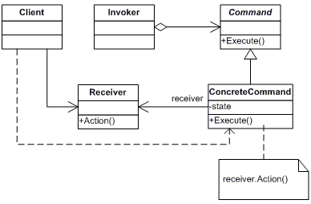

Exemple :

using System;
using System.Collections;
abstract class Command
{
// Methods
abstract public void Execute();
abstract public void UnExecute();
}
class CalculatorCommand : Command
{
// Fields
char @operator;
int operand;
Calculator calculator;
// Constructor
public CalculatorCommand( Calculator calculator,
char @operator, int operand )
{
this.calculator = calculator;
this.@operator = @operator;
this.operand = operand;
}
// Properties
public char Operator
{
set{ @operator = value; }
}
public int Operand
{
set{ operand = value; }
}
// Methods
override public void Execute()
{

calculator.Operation( @operator, operand );
}
override public void UnExecute()
{
calculator.Operation( Undo( @operator ), operand );
}
// Private helper function
private char Undo( char @operator )
{
char undo = ' ';
switch( @operator )
{
case '+': undo = '-'; break;
case '-': undo = '+'; break;
case '*': undo = '/'; break;
case '/': undo = '*'; break;
}
return undo;
}
}
class Calculator
{
// Fields
private int total = 0;
// Methods
public void Operation( char @operator, int operand )
{
switch( @operator )
{
case '+': total += operand; break;
case '-': total -= operand; break;
case '*': total *= operand; break;
case '/': total /= operand; break;
}
Console.WriteLine( "Total = {0} (following {1} {2})",
total, @operator, operand );
}
}
// "Invoker"
class User
{
// Fields
private Calculator calculator = new Calculator();
private ArrayList commands = new ArrayList();
private int current = 0;
// Methods
public void Redo( int levels )
{
Console.WriteLine( "---- Redo {0} levels ", levels );
// Perform redo operations
for( int i = 0; i < levels; i++ )
if( current < commands.Count - 1 )
((Command)commands[ current++ ]).Execute();
}
public void Undo( int levels )
{
Console.WriteLine( "---- Undo {0} levels ", levels );
// Perform undo operations
for( int i = 0; i < levels; i++ )
if( current > 0 )
((Command)commands[ --current ]).UnExecute();
}
public void Compute( char @operator, int operand )
{
// Create command operation and execute it
Command command = new CalculatorCommand(
calculator, @operator, operand );
command.Execute();
// Add command to undo list
commands.Add( command );
current++;
}
}
public class App
{
public static void Main( string[] args )
{
// Create user and let her compute
User user = new User();
user.Compute( '+', 100 );
user.Compute( '-', 50 );
user.Compute( '*', 10 );
user.Compute( '/', 2 );
// Undo and then redo some commands
user.Undo( 4 );
user.Redo( 3 );
}
}
Output
Total = 100 (following + 100)
Total = 50 (following - 50)
Total = 500 (following * 10)
Total = 250 (following / 2)
---- Undo 4 levels
Total = 500 (following * 2)
Total = 50 (following / 10)
Total = 100 (following + 50)
Total = 0 (following - 100)
---- Redo 3 levels
Total = 100 (following + 100)
Total = 50 (following - 50)
Total = 500 (following * 10)

Nom : Itérateur (Iterator)
Type : Comportement
Fréquence d’utilisation : 5/5
Description : Présente une façon d’accéder séquentiellement aux éléments d’un ensemble sans tenir compte de la structure interne de cet ensemble.
Diagramme UML :

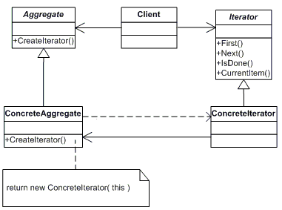

Exemple :

using System;
using System.Collections;
class Item
{
// Fields
string name;
// Constructors
public Item( string name )
{
this.name = name;
}
// Properties
public string Name
{
get{ return name; }
}
}
abstract class AbstractCollection
{
abstract public Iterator CreateIterator();
}
class Collection : AbstractCollection
{
// Fields
private ArrayList items = new ArrayList();
// Methods
public override Iterator CreateIterator()
{
return new Iterator( this );
}
// Properties
public int Count
{
get{ return items.Count; }
}
// Indexers
public object this[ int index ]
{
get{ return items[ index ]; }
set{ items.Add( value ); }
}
}
abstract class AbstractIterator
{
// Methods
abstract public Item First();
abstract public Item Next();
abstract public bool IsDone();
abstract public Item CurrentItem();
}
class Iterator : AbstractIterator
{
// Fields
private Collection collection;
private int current = 0;
private int step = 1;
// Constructor
public Iterator( Collection collection )
{
this.collection = collection;
}
// Properties
public int Step
{
get{ return step; }
set{ step = value; }
}
// Methods
override public Item First()
{
current = 0;
return (Item)collection[ current ];
}
override public Item Next()
{
current += step;
if( !IsDone() )
return (Item)collection[ current ];
else
return null;
}
override public Item CurrentItem()
{
return (Item)collection[ current ];
}
override public bool IsDone()
{
return current >= collection.Count ? true : false ;
}
}
public class App
{
public static void Main(string[] args)
{
// Build a collection
Collection collection = new Collection();
collection[0] = new Item( "Item 0" );
collection[1] = new Item( "Item 1" );
collection[2] = new Item( "Item 2" );
collection[3] = new Item( "Item 3" );
collection[4] = new Item( "Item 4" );
collection[5] = new Item( "Item 5" );
collection[6] = new Item( "Item 6" );
collection[7] = new Item( "Item 7" );
collection[8] = new Item( "Item 8" );
// Create iterator
Iterator iterator = new Iterator( collection );
// Skip every other item
iterator.Step = 2;
// For loop using iterator
for( Item item = iterator.First();
!iterator.IsDone(); item = iterator.Next() )
{
Console.WriteLine( item.Name );
}
}
}
Output
Item 0
Item 2
Item 4
Item 6
Item 8

Nom : Observateur (Observer)
Type : Comportement
Fréquence d’utilisation : 5/5
Description : Défini une dépendance entre un objet et plusieurs autres pour que, lorsque l’état dudit objet change, tous les objets dépendants sont avisés et mis à jour automatiquement.
Diagramme UML :

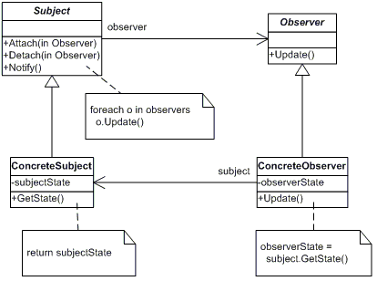

Exemple :

using System;
using System.Collections;
abstract class Stock
{
// Fields
protected string symbol;
protected double price;
private ArrayList investors = new ArrayList();
// Constructor
public Stock( string symbol, double price )
{
this.symbol = symbol;
this.price = price;
}
// Methods
public void Attach( Investor investor )
{
investors.Add( investor );
}
public void Detach( Investor investor )
{
investors.Remove( investor );
}
public void Notify()
{
foreach( Investor i in investors )
i.Update( this );
}

// Properties
public double Price
{
get{ return price; }
set{ price = value;
Notify(); }
}
public string Symbol
{
get{ return symbol; }
set{ symbol = value; }
}
}
class IBM : Stock
{
// Constructor
public IBM( string symbol, double price )
: base( symbol, price ) {}
}
interface IInvestor
{
void Update( Stock stock );
}
class Investor : IInvestor
{
// Fields
private string name;
private string observerState;
private Stock stock;
// Constructors
public Investor( string name )
{
this.name = name;
}
// Methods
public void Update( Stock stock )
{
Console.WriteLine( "Notified investor {0} of {1}'s " +
change to {2:C}", name, stock.Symbol, stock.Price );
}
// Properties
public Stock Stock
{
get{ return stock; }
set{ stock = value; }
}
}
public class App
{
public static void Main( string[] args )
{
// Create investors
Investor s = new Investor( "Sorros" );
Investor b = new Investor( "Berkshire" );
// Create IBM stock and attach investors
IBM ibm = new IBM( "IBM", 120.00 );
ibm.Attach( s );
ibm.Attach( b );
// Change price, which notifies investors
ibm.Price = 120.10;
ibm.Price = 121.00;
ibm.Price = 120.50;
ibm.Price = 120.75;
}
}
Output
Notified investor Sorros of IBM's change to $120.10
Notified investor Berkshire of IBM's change to $120.10
Notified investor Sorros of IBM's change to $121.00
Notified investor Berkshire of IBM's change to $121.00
Notified investor Sorros of IBM's change to $120.50
Notified investor Berkshire of IBM's change to $120.50
Notified investor Sorros of IBM's change to $120.75
Notified investor Berkshire of IBM's change to $120.75

Nom : État (State)
Type : Comportement
Fréquence d’utilisation : 4/5
Description : Permet à un objet de modifier son comportement lorsque son état interne change. La différence de comportement est alors reléguée à l’objet représentant le nouvel état.
Diagramme UML :

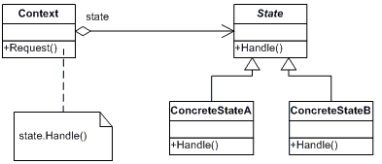

Exemple :

using System;
abstract class State
{
// Fields
protected Account account;
protected double balance;
protected double interest;
protected double lowerLimit;
protected double upperLimit;
// Properties
public Account Account
{
get{ return account; }
set{ account = value; }
}
public double Balance
{
get{ return balance; }
set{ balance = value; }
}
// Methods
abstract public void Initialize();
abstract public void Deposit( double amount );
abstract public void Withdraw( double amount );
abstract public void PayInterest();
abstract public void StateChangeCheck();
}
class RedState : State
{
// Fields
double serviceFee;
// Constructors
public RedState( State state )
{
this.balance = state.Balance;
this.account = state.Account;
Initialize();
}
// Methods
override public void Initialize()
{
// Should come from a database
interest = 0.0;
lowerLimit = -100.0;
upperLimit = 0.0;
serviceFee = 15.00;
}
override public void Deposit( double amount )
{
balance += amount;
StateChangeCheck();
}
override public void Withdraw( double amount )
{
amount = amount - serviceFee;
Console.WriteLine(
"No funds available to withdraw!" );
}
override public void PayInterest()
{
// No interest is paid
}
override public void StateChangeCheck()
{
if( balance > upperLimit )
account.State = new SilverState( this );
}
}
// Silver is non-interest bearing state
class SilverState : State
{
// Constructors
public SilverState(
double balance, Account account )
{
this.balance = balance;
this.account = account;
Initialize();
}
public SilverState( State state )
{
this.balance = state.Balance;
this.account = state.Account;
Initialize();
}
// Methods
override public void Initialize()
{
// Should come from a database
interest = 0.0;
lowerLimit = 0.0;
upperLimit = 1000.0;
}
override public void Deposit( double amount )
{
balance += amount;
StateChangeCheck();
}
override public void Withdraw( double amount )
{
balance -= amount;
StateChangeCheck();
}
override public void PayInterest()
{
balance += interest * balance;
StateChangeCheck();
}
override public void StateChangeCheck()
{
if( balance < lowerLimit )
account.State = new RedState( this );
else if( balance > upperLimit )
account.State = new GoldState( this );
}
}
// Interest bearing state
class GoldState : State
{
// Constructors
public GoldState(
double balance, Account account )
{
this.balance = balance;
this.account = account;
Initialize();
}
public GoldState( State state )
{
this.balance = state.Balance;
this.account = state.Account;
Initialize();
}
// Methods
override public void Initialize()
{
// Should come from a database
interest = 0.05;
lowerLimit = 1000.0;
upperLimit = 10000000.0;
}
override public void Deposit( double amount )
{
balance += amount;
StateChangeCheck();
}
override public void Withdraw( double amount )
{
balance -= amount;
StateChangeCheck();
}
override public void PayInterest()
{
balance += interest * balance;
StateChangeCheck();
}
override public void StateChangeCheck()
{
if( balance < 0.0 )
account.State = new RedState( this );
else if( balance < lowerLimit )
account.State = new SilverState( this );
}
}
class Account
{
// Fields
private State state;
private string owner;
// Constructors
public Account( string owner )
{
// New accounts are 'Silver' by default
this.owner = owner;
state = new SilverState( 0.0, this );
}
// Properties
public double Balance
{
get{ return state.Balance; }
}
public State State
{
get{ return state; }
set{ state = value; }
}
// Methods
public void Deposit( double amount )
{
state.Deposit( amount );
Console.WriteLine( "Deposited {0:C} --- ",
amount);
Console.WriteLine( " Balance = {0:C}",
this.Balance );
Console.WriteLine( " Status = {0}" ,
this.State );
Console.WriteLine( "" );
}
public void Withdraw( double amount )
{
state.Withdraw( amount );
Console.WriteLine( "Withdrew {0:C} --- ",
amount);
Console.WriteLine( " Balance = {0:C}",
this.Balance );
Console.WriteLine( " Status = {0}" ,
this.State );
Console.WriteLine( "" );
}
public void PayInterest()
{
state.PayInterest();
Console.WriteLine( "Interest Paid --- ");
Console.WriteLine( " Balance = {0:C}",
this.Balance );
Console.WriteLine( " Status = {0}" ,
this.State );
Console.WriteLine( "" );
}
}
public class App
{
public static void Main( string[] args )
{
// Open a new account
Account account = new Account( "Ana Micola" );
// Apply financial transactions
account.Deposit( 500.0 );
account.Deposit( 300.0 );
account.Deposit( 550.0 );
account.PayInterest();
account.Withdraw( 2000.00 );
account.Withdraw( 1100.00 );
}
}
Output
Deposited $500.00 ---
Balance = $500.00
Status = SilverState
Deposited $300.00 ---
Balance = $800.00
Status = SilverState
Deposited $550.00 ---
Balance = $1,350.00
Status = GoldState
Interest Paid ---
Balance = $1,417.50
Status = GoldState
Withdrew $2,000.00 ---
Balance = ($582.50)
Status = RedState
No funds available to withdraw!
Withdrew $1,100.00 ---
Balance = ($582.50)
Status = RedState

Nom : Stratégie (Strategy)
Type : Comportement
Fréquence d’utilisation : 4/5
Description : Permet d’encapsuler et de rendre interchangeables une famille d’algorithmes. Stratégie permet à l’algorithme de varier indépendamment du client qui l’utilise.

Diagramme UML :

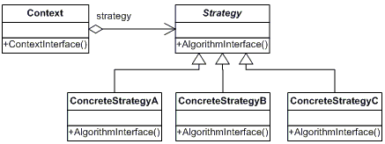

Exemple :

using System;
using System.Collections;
abstract class SortStrategy
{
abstract public void Sort( ArrayList list );
}
class QuickSort : SortStrategy
{
public override void Sort(ArrayList list )
{
list.Sort(); // Default is Quicksort
Console.WriteLine("QuickSorted list ");
}
}
class ShellSort : SortStrategy
{
public override void Sort(ArrayList list )
{
//list.ShellSort();
Console.WriteLine("ShellSorted list ");
}
}
class MergeSort : SortStrategy
{
public override void Sort( ArrayList list )
{
//list.MergeSort();
Console.WriteLine("MergeSorted list ");
}
}
class SortedList
{
// Fields
private ArrayList list = new ArrayList();
private SortStrategy sortstrategy;
// Constructors
public void SetSortStrategy( SortStrategy sortstrategy )
{
this.sortstrategy = sortstrategy;
}
public void Sort()
{
sortstrategy.Sort( list );
}
public void Add( string name )
{
list.Add( name );
}
public void Display()
{
foreach( string name in list )
Console.WriteLine( " " + name );
}
}
public class App
{
public static void Main( string[] args )
{
// Two contexts following different strategies
SortedList studentRecords = new SortedList( );
studentRecords.Add( "Samual" );
studentRecords.Add( "Jimmy" );
studentRecords.Add( "Sandra" );
studentRecords.Add( "Anna" );
studentRecords.Add( "Vivek" );
studentRecords.SetSortStrategy( new QuickSort() );
studentRecords.Sort();
studentRecords.Display();
}
}
Output
QuickSorted list
Anna
Jimmy
Samual
Sandra
Vivek

Nom : Modèle de méthode (Template Method)
Type : Comportement
Fréquence d’utilisation : 5/5
Description : Défini le squelette d’un algorithme en reléguant certaines étapes aux classes dérivées. Le modèle de méthode permet aux classes dérivées de redéfinir certaines parties de l’algorithme sans changer sa structure générale.
Diagramme UML :

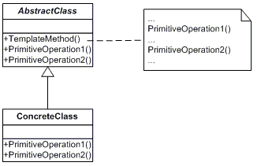

Exemple :

using System;
using System.Data;
using System.Data.OleDb;
abstract class DataObject
{
// Methods
abstract public void Connect();
abstract public void Select();
abstract public void Process();
abstract public void Disconnect();
// The "Template Method"
public void Run()
{
Connect();
Select();
Process();
Disconnect();
}
}
class CustomerDataObject : DataObject
{
private string connectionString =
"provider=Microsoft.JET.OLEDB.4.0; "
+ "data source=c:\\nwind.mdb";
private string commandString;
private DataSet dataSet;
// Methods
public override void Connect( )
{
}
public override void Select( )
{
commandString = "select CompanyName from Customers";
OleDbDataAdapter dataAdapter = new OleDbDataAdapter(
commandString, connectionString );
dataSet = new DataSet();
dataAdapter.Fill( dataSet, "Customers" );
}
public override void Process()
{
DataTable dataTable = dataSet.Tables["Customers"];
foreach( DataRow dataRow in dataTable.Rows )
Console.WriteLine( dataRow[ "CompanyName" ] );
}
public override void Disconnect()
{
}
}
public class App
{
public static void Main( string[] args )
{
CustomerDataObject c = new CustomerDataObject( );
c.Run();
}
}
Output
Alfreds Futterkiste
Ana Trujillo Emparedados y helados
Antonio Moreno Taquería
Around the Horn
Berglunds snabbköp
Blauer See Delikatessen
Blondel père et fils
Bólido Comidas preparadas
Bon app'
Bottom-Dollar Markets
B's Beverages
Cactus Comidas para llevar
Centro comercial Moctezuma
Chop-suey Chinese
...

